1. Write a Python program to reverse the content of the string.

Do not use built in

def reverse_string(input_string):

# Initialize an empty string to store the reversed content

reversed_string = ''

# Loop through the input string from the end to the start

for i in range(len(input_string) - 1, -1, -1):

reversed_string += input_string[i]

return reversed_string

# Example usage

original_string = "Hello, World!"

reversed_string = reverse_string(original_string)

print("Original String:", original_string)

print("Reversed String:", reversed_string)

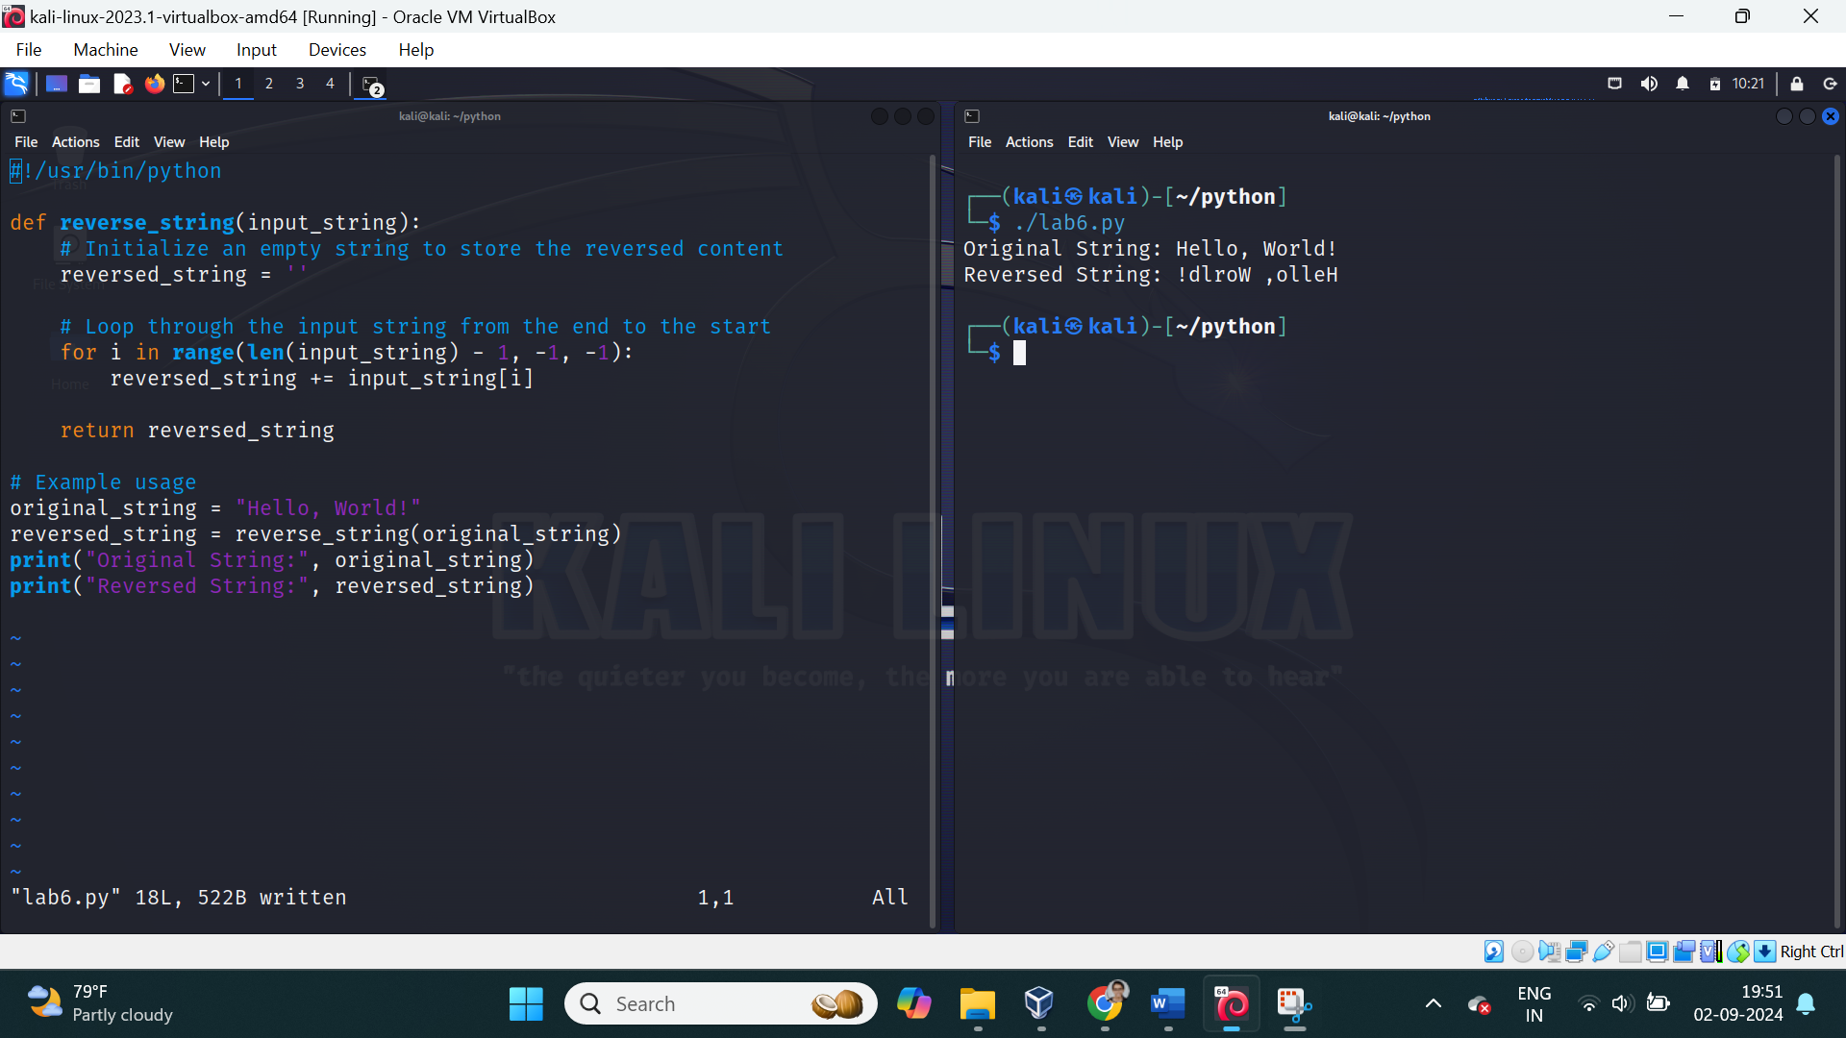

2. Create a program that performs basic string compression using the counts of repeated characters. For example, the string “aabcccccaaa” would become “a2b1c5a3”.

def compress_string(input_string):

# Initialize an empty string for the compressed result

compressed = ""

# Initialize a counter for consecutive characters

count = 1

# Loop through the string

for i in range(1, len(input_string)):

# If the current character is the same as the previous one

if input_string[i] == input_string[i - 1]:

count += 1

else:

# Append the previous character and its count to the result

compressed += input_string[i - 1] + str(count)

count = 1 # Reset the count

# Don't forget to add the last set of characters

compressed += input_string[-1] + str(count)

return compressed

# Example usage

original_string = "aabcccccaaa"

compressed_string = compress_string(original_string)

print("Original String:", original_string)

print("Compressed String:", compressed_string)

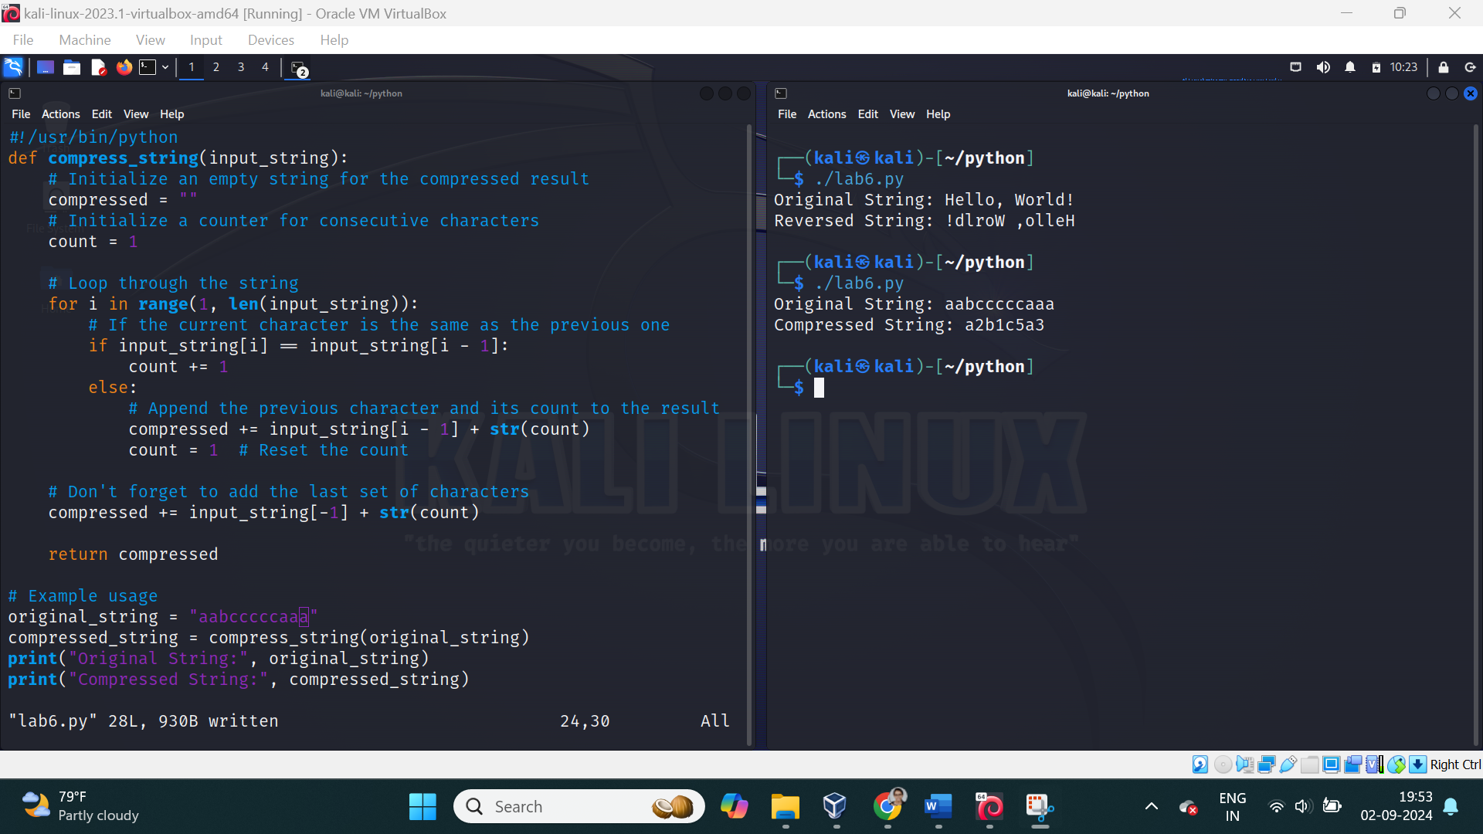

3. Get the Caesar cipher from the user Decrypt the cipher

def decrypt_caesar_cipher(cipher_text, shift):

decrypted_text = ""

for char in cipher_text:

# Check if the character is an uppercase letter

if 'A' <= char <= 'Z':

decrypted_char = chr((ord(char) - shift - 65) % 26 + 65)

# Check if the character is a lowercase letter

elif 'a' <= char <= 'z':

decrypted_char = chr((ord(char) - shift - 97) % 26 + 97)

else:

# If it's not a letter, don't change it

decrypted_char = char

decrypted_text += decrypted_char

return decrypted_text

# Get the cipher text and shift from the user

cipher_text = input("Enter the Caesar cipher text: ")

shift = int(input("Enter the shift value used in the cipher: "))

# Decrypt the cipher

decrypted_text = decrypt_caesar_cipher(cipher_text, shift)

print("Decrypted Text:", decrypted_text)

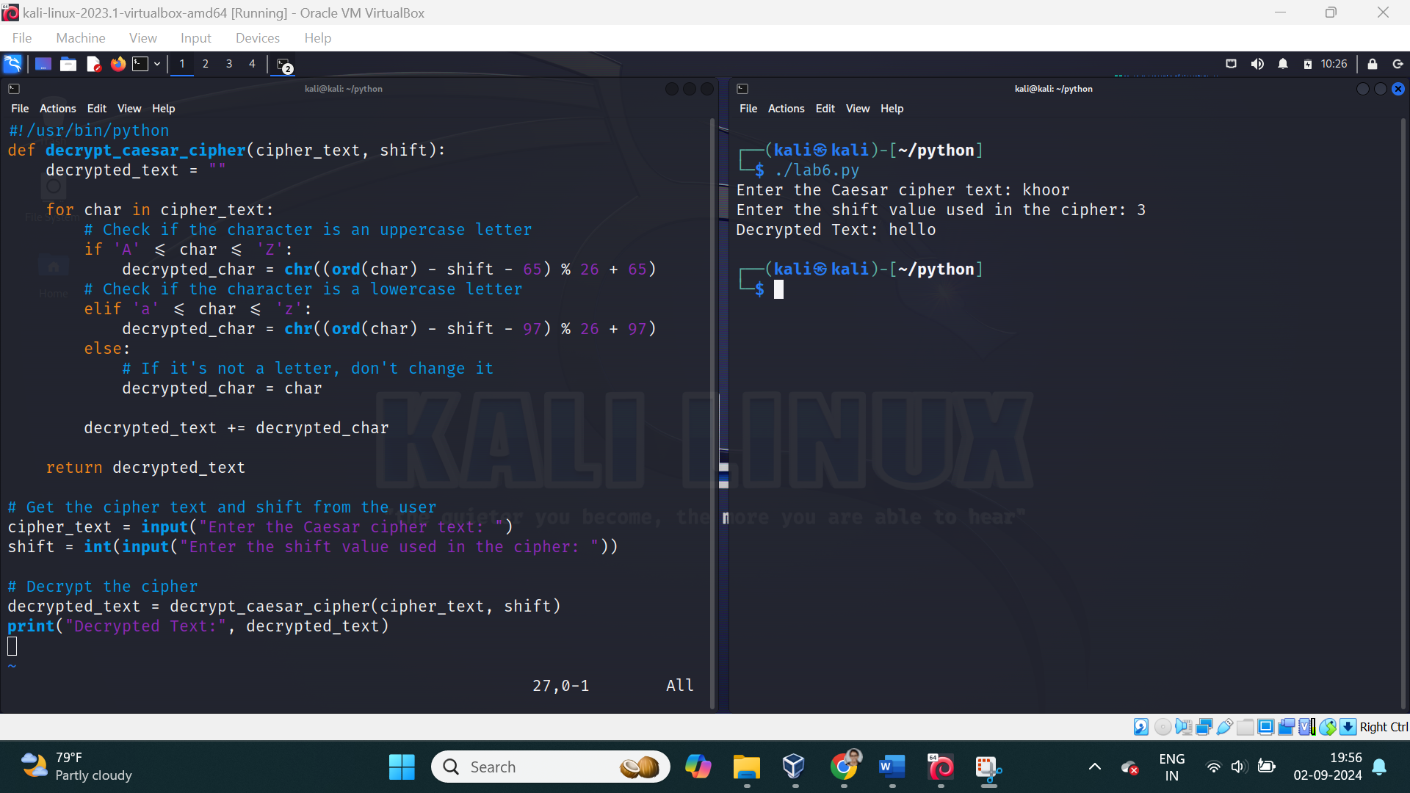

4. Get the cipher encrypted using shift cipher. Identify the key used to encrypt using brute force

ie all the values in the key space

def decrypt_caesar_cipher(cipher_text, shift):

decrypted_text = ""

for char in cipher_text:

# Check if the character is an uppercase letter

if 'A' <= char <= 'Z':

decrypted_char = chr((ord(char) - shift - 65) % 26 + 65)

# Check if the character is a lowercase letter

elif 'a' <= char <= 'z':

decrypted_char = chr((ord(char) - shift - 97) % 26 + 97)

else:

# If it's not a letter, don't change it

decrypted_char = char

decrypted_text += decrypted_char

return decrypted_text

def brute_force_caesar(cipher_text):

for shift in range(1, 26):

decrypted_text = decrypt_caesar_cipher(cipher_text, shift)

print(f"Key {shift}: {decrypted_text}")

# Get the cipher text from the user

cipher_text = input("Enter the Caesar cipher text: ")

# Perform brute force attack to identify the key

brute_force_caesar(cipher_text)

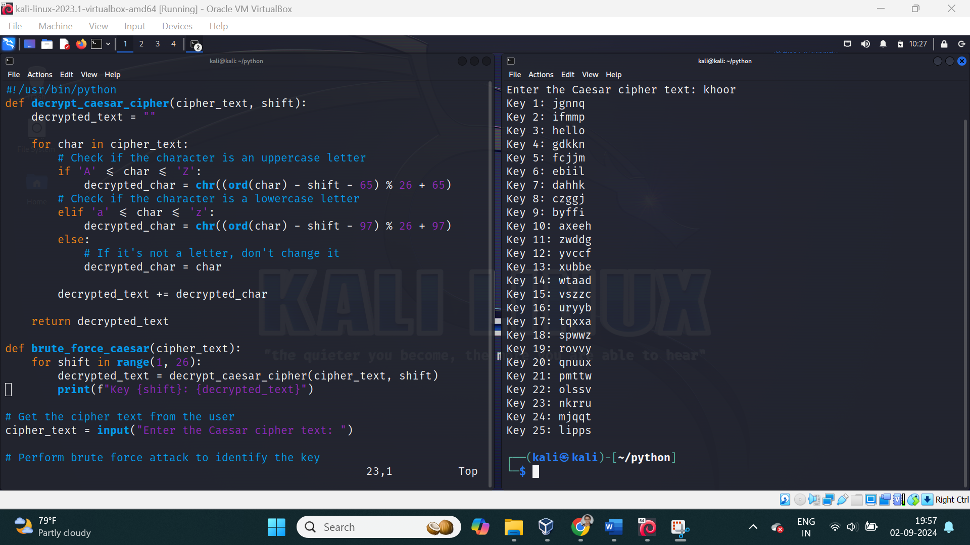

5. Find the k value , Provided cipher text and plain text

def find_shift_value(plain_text, cipher_text):

# Assuming plain_text and cipher_text are of the same length

shift_values = []

for pt_char, ct_char in zip(plain_text, cipher_text):

if pt_char.isalpha(): # Only consider alphabetic characters

# Calculate the shift value for uppercase letters

if pt_char.isupper():

shift = (ord(ct_char) - ord(pt_char)) % 26

# Calculate the shift value for lowercase letters

elif pt_char.islower():

shift = (ord(ct_char) - ord(pt_char)) % 26

shift_values.append(shift)

# If all shifts are the same, return that shift value

if all(s == shift_values[0] for s in shift_values):

return shift_values[0]

else:

return "Inconsistent shifts found!"

# Example usage

plain_text = input("Enter the plain text: ")

cipher_text = input("Enter the cipher text: ")

k_value = find_shift_value(plain_text, cipher_text)

if isinstance(k_value, int):

print(f"The shift value (k) used for encryption is: {k_value}")

else:

print(k_value)

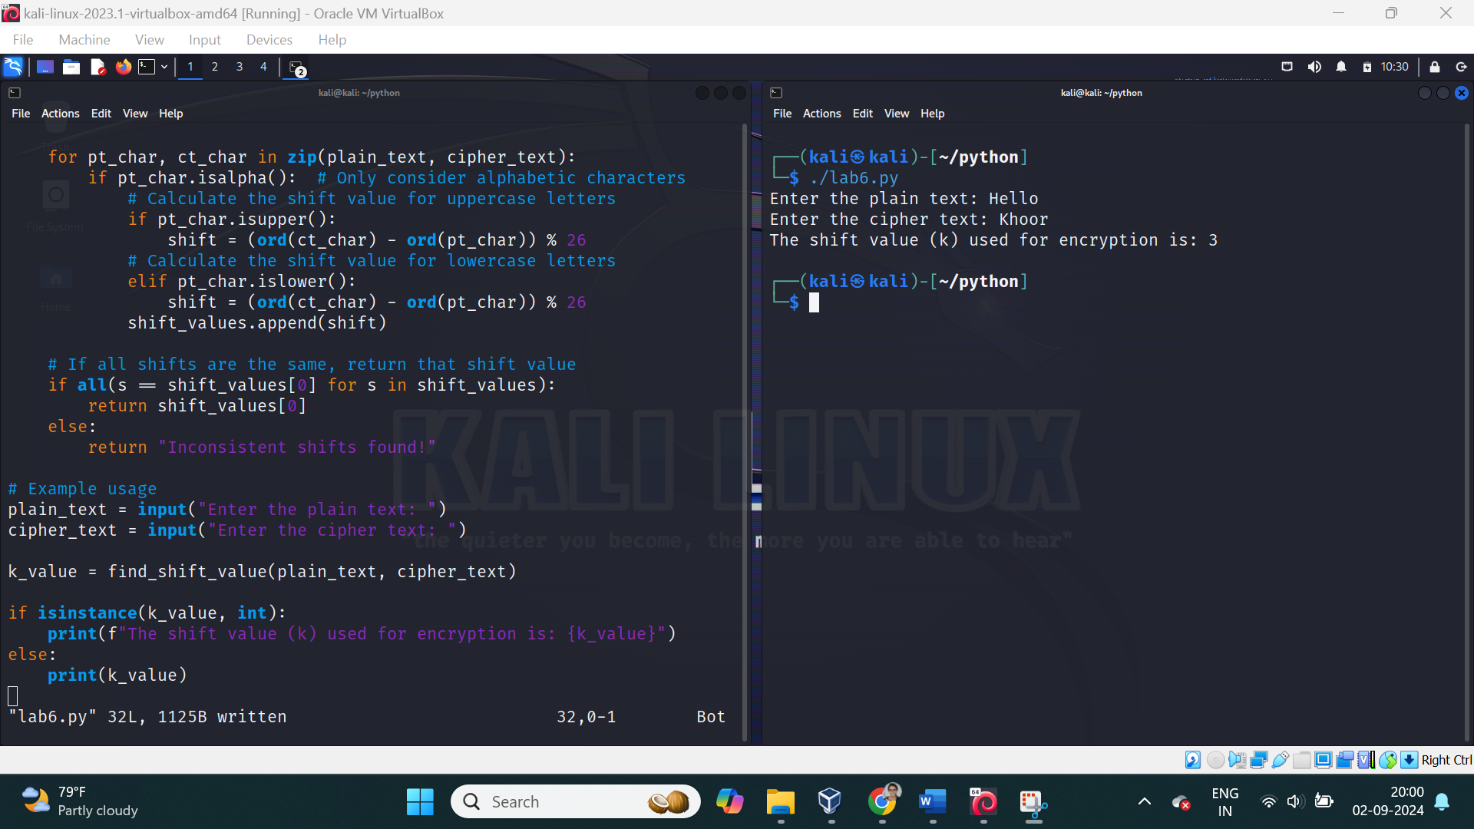

6. Encrypt and decrypt the string using Atbash cipher

def atbash_cipher(text):

encrypted_decrypted_text = ""

for char in text:

if char.isalpha():

# For uppercase letters

if char.isupper():

encrypted_decrypted_text += chr(65 + (25 - (ord(char) - 65)))

# For lowercase letters

else:

encrypted_decrypted_text += chr(97 + (25 - (ord(char) - 97)))

else:

# Non-alphabetic characters remain the same

encrypted_decrypted_text += char

return encrypted_decrypted_text

# Example usage

text = input("Enter the text to encrypt/decrypt using Atbash cipher: ")

result = atbash_cipher(text)

print("Result:", result)

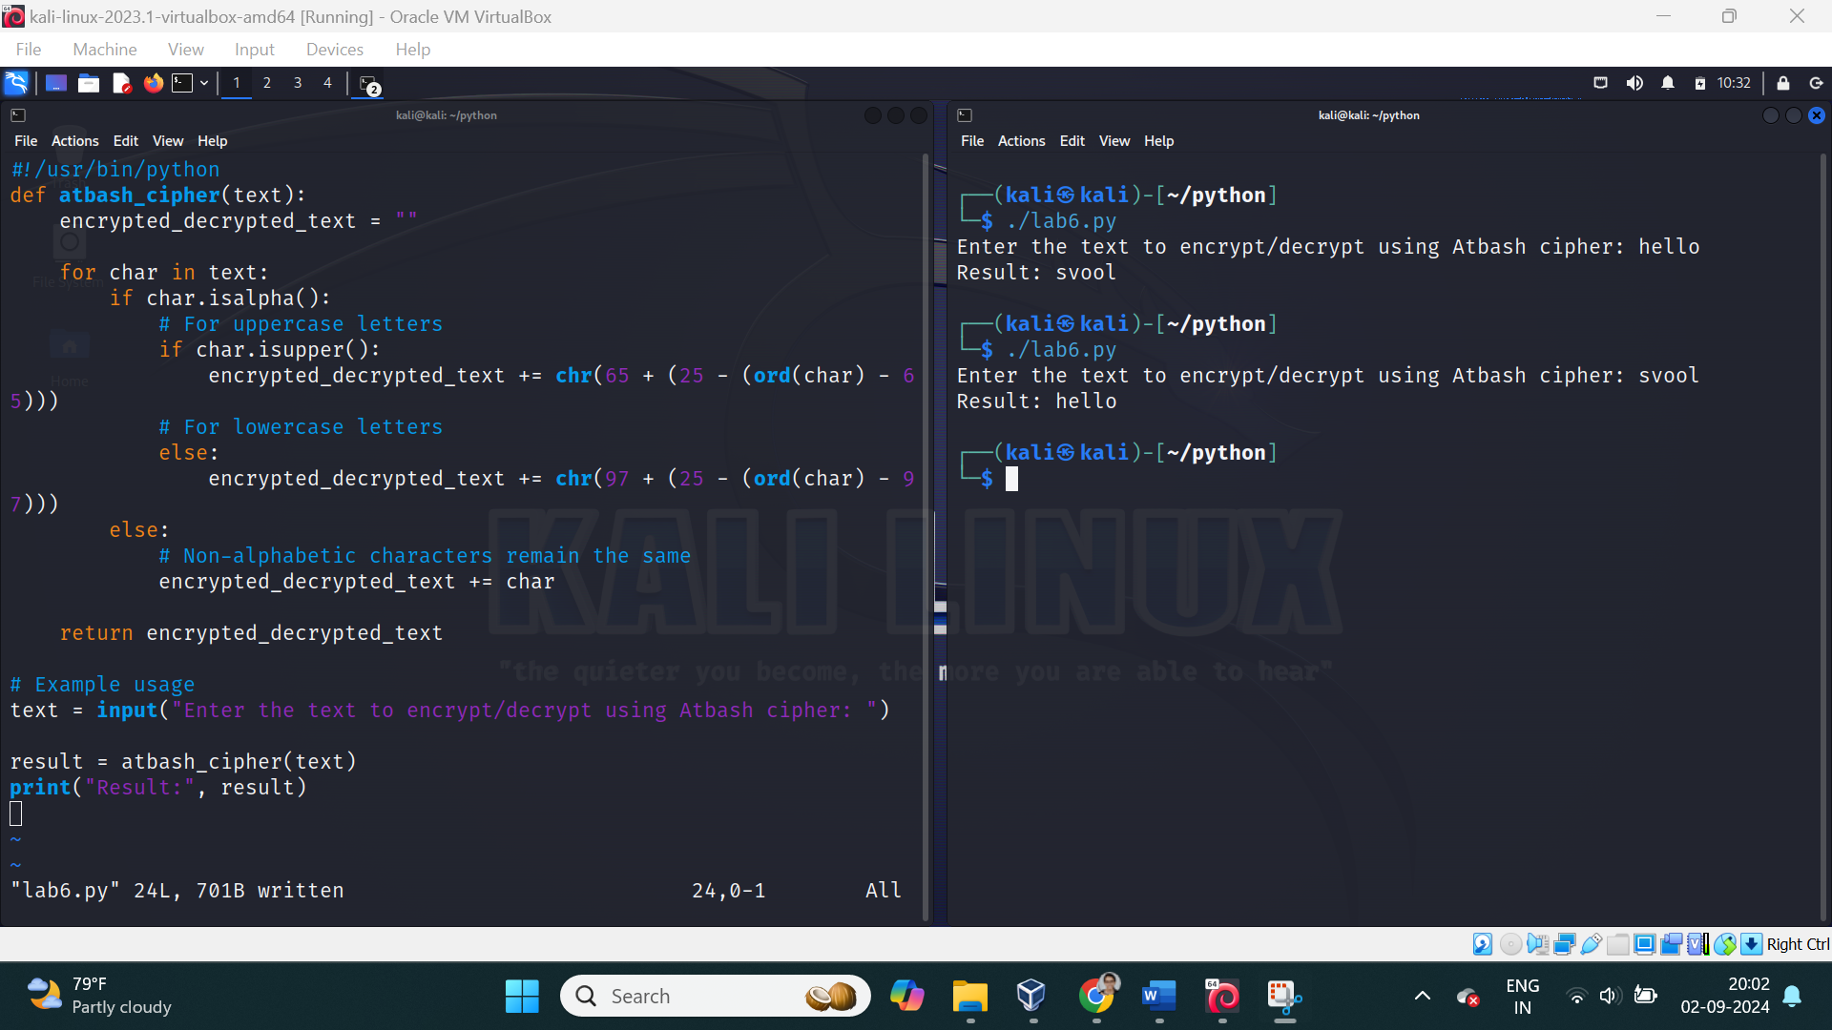

7. Encrypt and decrypt using Affine cipher

add validation

def mod_inverse(a, m):

for i in range(1, m):

if (a * i) % m == 1:

return i

return None

def affine_encrypt(plain_text, a, b):

if mod_inverse(a, 26) is None:

raise ValueError("The key 'a' must be coprime with 26 for the Affine cipher to work.")

encrypted_text = ""

for char in plain_text:

if char.isalpha():

if char.isupper():

x = ord(char) - 65

encrypted_char = chr(((a * x + b) % 26) + 65)

else:

x = ord(char) - 97

encrypted_char = chr(((a * x + b) % 26) + 97)

encrypted_text += encrypted_char

else:

encrypted_text += char

return encrypted_text

def affine_decrypt(cipher_text, a, b):

a_inv = mod_inverse(a, 26)

if a_inv is None:

raise ValueError("The key 'a' must be coprime with 26 for the Affine cipher to work.")

decrypted_text = ""

for char in cipher_text:

if char.isalpha():

if char.isupper():

y = ord(char) - 65

decrypted_char = chr(((a_inv * (y - b)) % 26) + 65)

else:

y = ord(char) - 97

decrypted_char = chr(((a_inv * (y - b)) % 26) + 97)

decrypted_text += decrypted_char

else:

decrypted_text += char

return decrypted_text

# Validate and get inputs

while True:

try:

a = int(input("Enter the key 'a' (must be coprime with 26): "))

b = int(input("Enter the key 'b': "))

if mod_inverse(a, 26) is None:

raise ValueError("Invalid 'a' value. It must be coprime with 26.")

break

except ValueError as ve:

print(ve)

# Get the text to encrypt/decrypt

plain_text = input("Enter the text to encrypt: ")

# Encryption

encrypted_text = affine_encrypt(plain_text, a, b)

print(f"Encrypted Text: {encrypted_text}")

# Decryption

decrypted_text = affine_decrypt(encrypted_text, a, b)

print(f"Decrypted Text: {decrypted_text}")

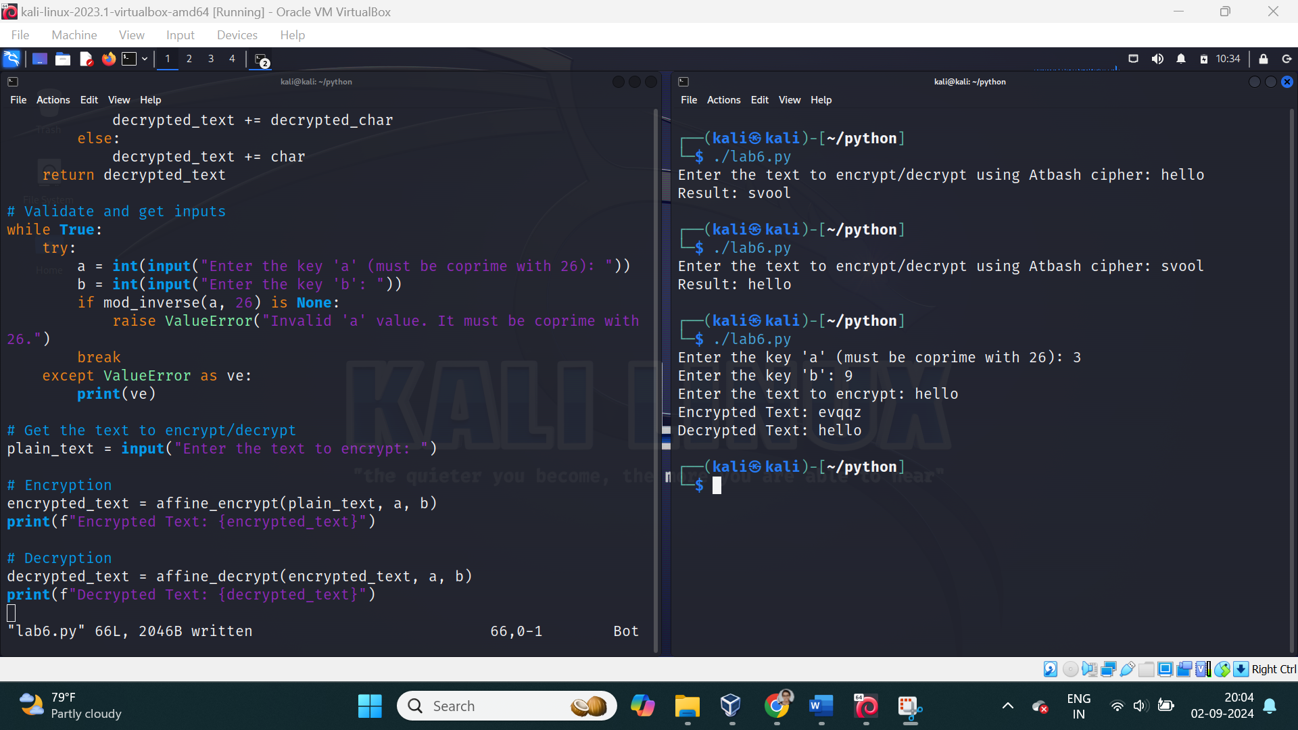

The harder you work for something, the greater you will feel when you achieve it.

Do not limit your challenges challenge your limit